Worksheet 2: Inputs, Processes and Outputs

Activity 1: Identify the inputs, processes and outputs for the following real-world applications:

Passport Scanner (Details)
Input: Passport barcode is scanned
Process: Data from barcode is checked against national database
Output:

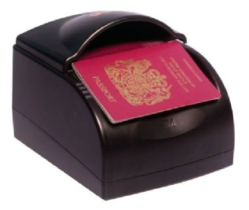

Fingerprint Clocking-in or Registration System (Details)
Input: Fingerprint on sensor
Process:

Output:

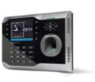
Automatic Windscreen Wiper (Details)
Input:

Process:

Output: Wipers switch on
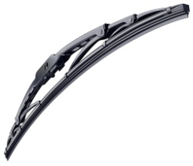

Automatic Smoke Detector (Details)
Input:

Process:

Output:

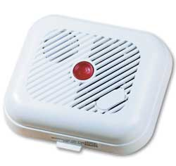

Activity 2:
- Identify all of the Input devices at a supermarket self-checkout machine. What data is input for each device?
Input Device | What data is input?

- What information needs to be stored on the supermarket computer in order to make everything work correctly?

- Where might this data is stored?

- What type of storage device could the data be stored on and why?

- Identify the Output devices at a supermarket and state what the output would be.
Output Device | What data is output?

